**AddressIQ API - Database Connection Table Mode - Postman Testing Steps**

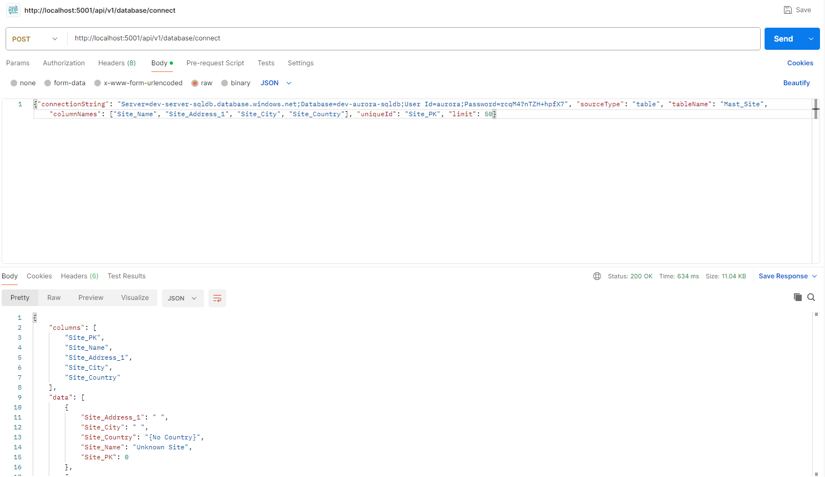

**STEP 1: Open Postman**

* Launch Postman application
* Create a new request

**STEP 2: Configure Request Method**

* Set Method to: POST

*← In screenshot: Method dropdown set to "POST" (USER FILLS THIS)*

**STEP 3: Enter API URL**

* Enter URL: http://localhost:5001/api/v1/database/connect

*← In screenshot: URL bar with the API endpoint (USER FILLS THIS)*

**STEP 4: Configure Request Headers**

* Click on "Headers" tab
* Add header: Content-Type = application/json
* Add header: X-API-Key = your-api-key

*← In screenshot: Headers tab with Content-Type and X-API-Key headers (USER ADDS THIS)*

**STEP 5: Configure Request Body**

* Click on "Body" tab
* Select "raw" option
* Select "JSON" from dropdown

*← In screenshot: Body tab with "raw" and "JSON" selected (USER SELECTS THIS)*

* Enter the JSON payload:

{

"connectionString": "Server=localhost;Database=MyDB;User Id=user;Password=pass;TrustServerCertificate=True;",

"sourceType": "table",

"tableName": "Mast_Site",

"columnNames": ["Site_Name", "Site_Address_1", "Site_City", "Site_Country"],

"uniqueId": "Site_PK",

"limit": 50

}

*← In screenshot: JSON payload in body area (USER TYPES THIS)*

**STEP 6: Send Request**

* Click the blue "Send" button
* Wait for processing (typically 2-10 seconds depending on database size)

*← In screenshot: Status "200 OK" and response data (SHOWS SUCCESS)*

**STEP 7: Review Response**

* Check response contains actual database records
* Verify data array has the requested columns
* Note the row_count showing number of records returned
* Check query_executed field shows the generated SQL

*← In screenshot: Response body with database records (PROCESSED RESULT)*

**SUCCESS INDICATORS:**

* Status: 200 OK (shown in screenshot)
* Response contains "success": true
* Data array contains actual database records
* Row_count field shows number of records returned
* Columns array lists the requested column names
* Query_executed shows the generated SQL query
* Processing time typically 2-10 seconds depending on database size

**TROUBLESHOOTING:**

* If you get "400 Bad Request" error → Check JSON format, required fields (connectionString, sourceType, tableName, columnNames), and Content-Type header
* If you get "401 Unauthorized" error → Add X-API-Key header with valid API key
* If you get connection error → Make sure server is running on localhost:5001
* If database connection fails → Verify connection string format, server accessibility, and credentials
* If table not found error → Check table name spelling and verify table exists in specified database
* If column not found error → Verify column names exist in the specified table
* If no data returned → Table may be empty, try removing limit or checking data exists

**That's it! Your database table data will be fetched and returned with the exact columns you specified.**